

***To be printed on hospital headed paper***



**Information for children (guide ages: 8-10)**

**A-STAR: The UK-Irish Atopic eczema Systemic TherApy Register**

**We would like to ask you to take part in a study to see how different eczema medicines work. Before you decide, it is important for you to understand what the study is about, and what will happen to you if you take part. Please read this leaflet carefully and ask us about anything that you do not understand.**

**What is the study for?**

There are some medicines that are used to treat people with eczema. We want to know more about how these medicines work, and if they have any good or bad effects when taken for a short and long time.

We also want to see how these medicines compare with each other.

**Why have I been invited?**

 You have been invited because you have eczema and are about to take a new medicine.

**Do I have to take part?**

 You do not have to take part if you do not want to.

 If you decide not to take part it will not affect how your doctors and nurses treat you.

✪ If you **do** decide to take part, and your parents or carers agree, you can sign. a form to show this if you would like to.

You can change your mind at any time without saying why.

**Do I have to take part?**

 You do not have to take part if you do not want to.

 If you decide not to take part it will not affect how your doctors and nurses treat you.

✪ If you **do** decide to take part, and your parents or carers agree, you can sign a form to show this if you would like to.

You can change your mind at any time without saying why.

**Do I have to take part?**

 You do not have to take part if you do not want to.

 If you decide not to take part it will not affect how your doctors and nurses treat you.

✪ If you **do** decide to take part, and your parents or carers agree, you can sign. a form to show this if you would like to.

You can change your mind at any time without saying why.

The information that we would collect about you will be kept secret. We will keep your name locked in the study office to help check information.

MCj04241600000[1]

**What information will we collect from you?**

 The study will collect information about you, your eczema, medical treatment and tests and how well you are, for at least one year.

 All this information will come from the team you see for your eczema during your normal hospital visits. You will not have to answer many questions from us and your family or carer can help you with this. We will ask you to complete a sheet with questions during different visits.

 This type of study is called an ‘observational study’ which means that we simply watch what happens to you. It does not affect how your doctor treats you.

 If you agree, we may also collect a bit of extra blood for test. This can hurt a bit or cause a bit of itching, but this is usually mild. You do not need to have this blood tests if you don’t want to.

The results of the research will be written about in a medical journal, but not for a few years. Your doctor will be able to tell you about how the research is going, and nobody outside your treating team will know that your information is included in the study.

If you have any questions at all you can ask one of the people looking after you or your parents or carer, or visit our website http://astar-register.org

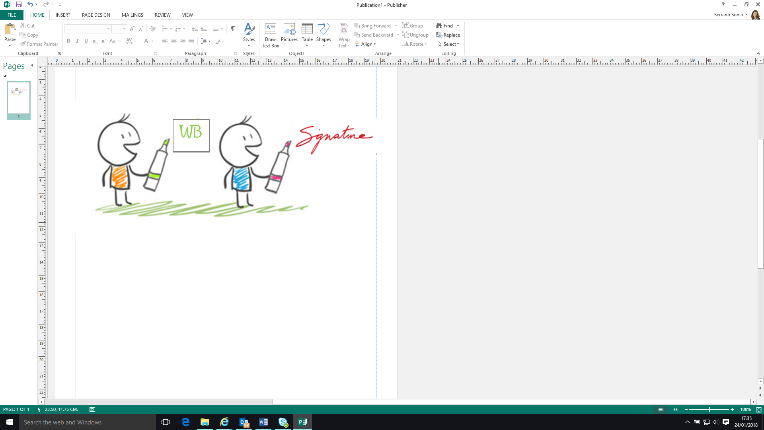

 

PATIENT ASSENT FORM *For individuals not legally able to agree to consent. To be signed alongside a Parent/Guardian Consent Form)*

**A-STAR: The UK-Irish Atopic eczema Systemic TherApy Register**

Or cross if you don’t agree

Initial box to agree

WB

X

I have read the study

information



I was able to ask questions

about the study



I know that I can stop taking part in the project at any time and it won’t affect how I am treated in the hospital and the nurses and doctors will not mind at all



I was told what I

wanted to know



I am happy to complete questionnaires



I want to take part in

the A*STAR study



**Your name:**

**Your**

**signature:**

**Date:**

I am OK to give some blood

Samples for research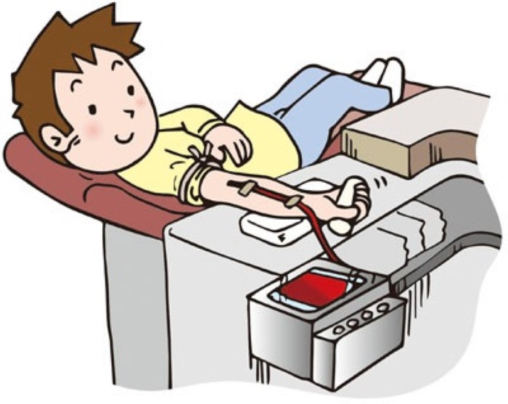

*1 copy for patient; 1 copy for researcher; 1 copy to be kept with hospital notes*