 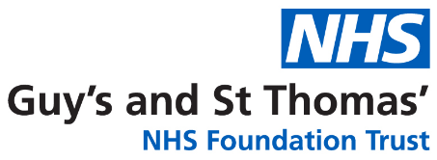

***To be printed on hospital headed paper***



Information for young children (Guide Age: 5-7 year olds)

**A-STAR: The UK-Irish Atopic eczema Systemic TherApy Register**

MCj04039830000[1]

**If you have any questions you can ask your mum, dad, carer, or one of the people taking care of you at the hospital.**

**THANKS FOR READING THIS!**

**If you let us we will also take a bit of blood from your arm; some children say it hurts a bit, others are not so bothered.**

**We will ask you some questions, which will be part of your normal hospital visit, but mum, dad or your carer can help you to answer these.**

**We want to see how these medicines affect you and your eczema over the next few years.**

**We would like to ask for your help with our project!**

**We want to find out how different types of medicines for eczema work.**

**We will get this information from the doctors and nurses you see for your eczema appointments.**



**COLOUR ME!**

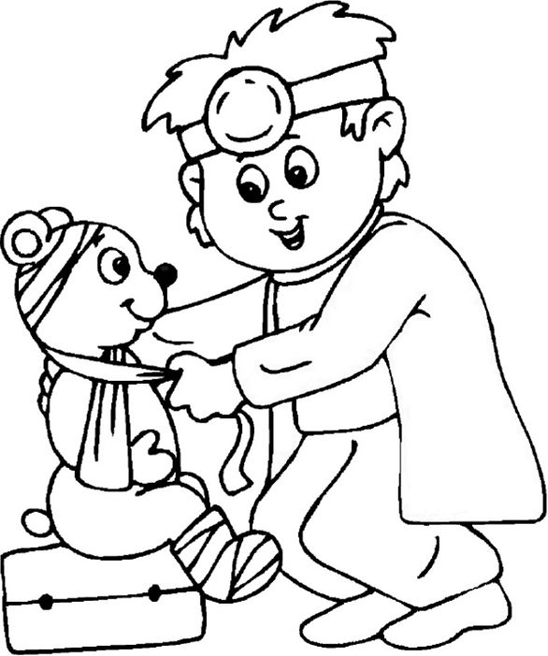

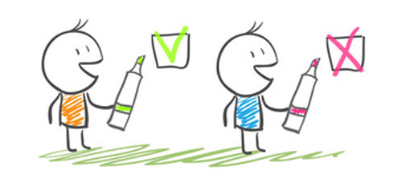



PATIENT ASSENT FORM

*(For individuals not legally able to agree to consent.*

*To be signed alongside a Parent/Guardian Consent Form)*

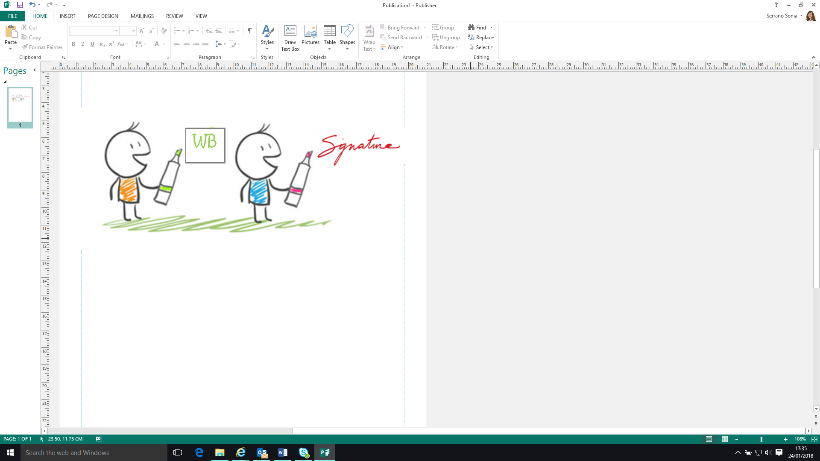

**The UK-Irish Atopic eczema Systemic TherApy Register (A-STAR)**

Or cross if you don’t agree

Initial box to agree

WB

X

All my questions have been answered



Do you want to help us?



Remember that you can stop helping if you want

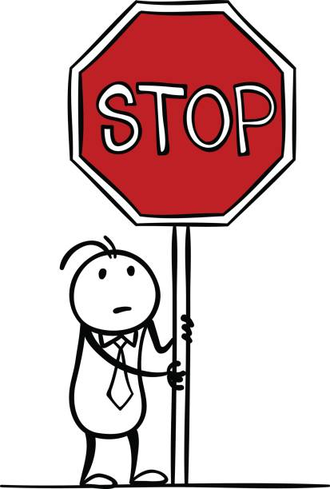

Are you happy to answer some questions for us?



**Your name:**

**Your**

**signature:**

**Date:**

Are you happy to give us some blood?

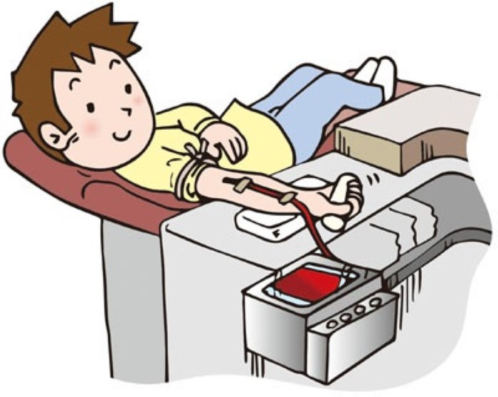

*1 copy for patient; 1 copy for researcher; 1 copy to be kept with hospital notes*